|  |  |
| --- | --- |
| Course Name | ITD 2263 – Graphical User Interface Development |
| Instructor | Daniel D. Claborn |
| Student Name | Derrick McFall |
| Due date | 01Oct17 |
| Grade | 0 |
| Grading Comments | <instructor comments here> |

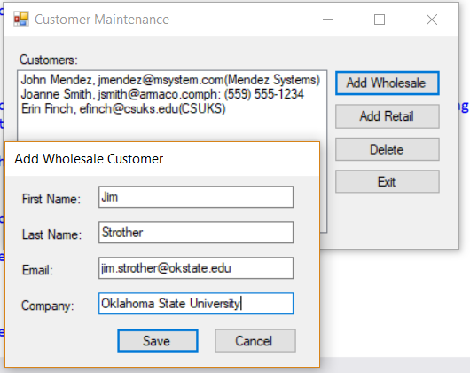

Using the add wholesale customer button

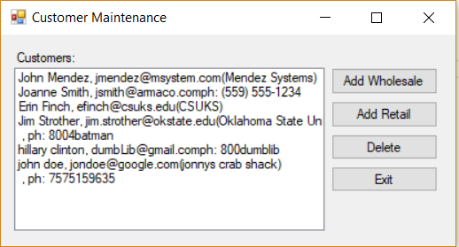

You can see that I was able to add jim Strother as a wholesale customer. But two of the retail customers only had phone numbers. I wasn’t using : base(string firstname, string lastname, string email) after my constructor. When adding that part in it started working exactly as intended.

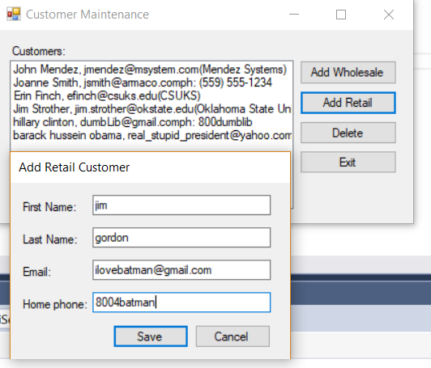

After removing the empty string names and email and correcting my problem with not calling the super constructor it worked.

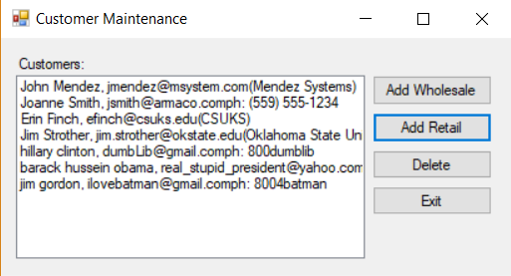

The police commissioner is now a customer of the retail type.

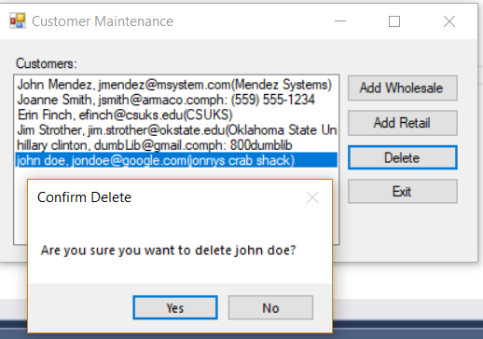

Making sure that my delete button works to remove john doe.

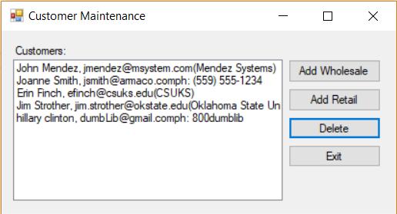

John doe is no longer a wholesale customer. We don’t like crabs.